**AWS SCREENSHOTS**

**AWS**

1. **AWS LOGIN SCREEN WITH USERNAME**

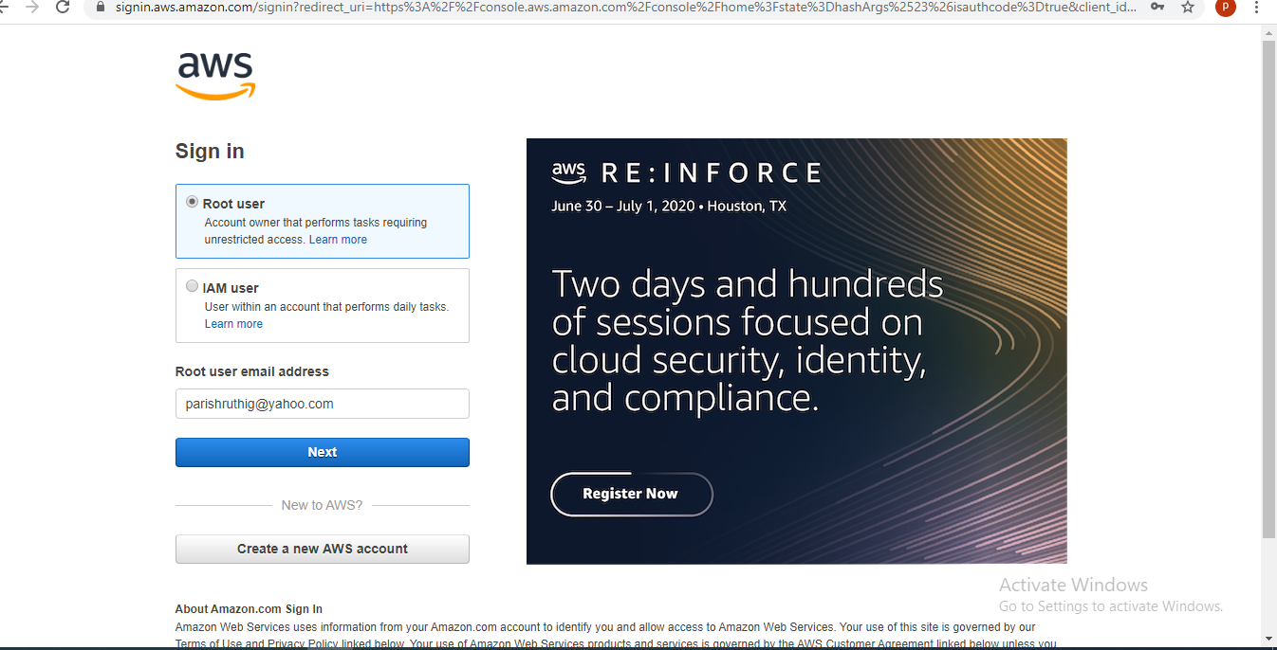

1. **EC2 DASHBOARD**

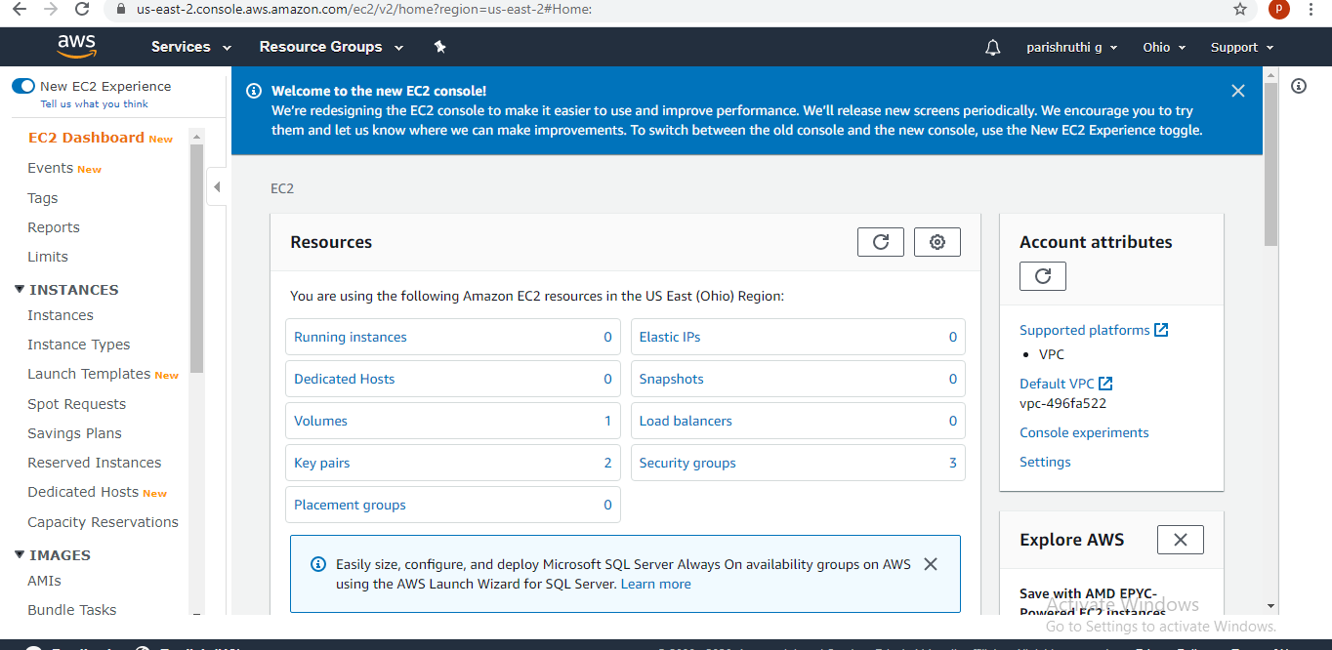

1. **S3 DASHBOARD**

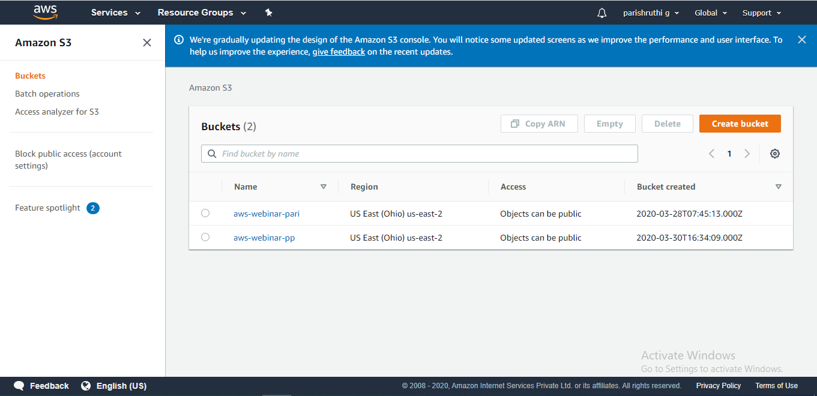

1. **REKOGNITION DASHBOARD**

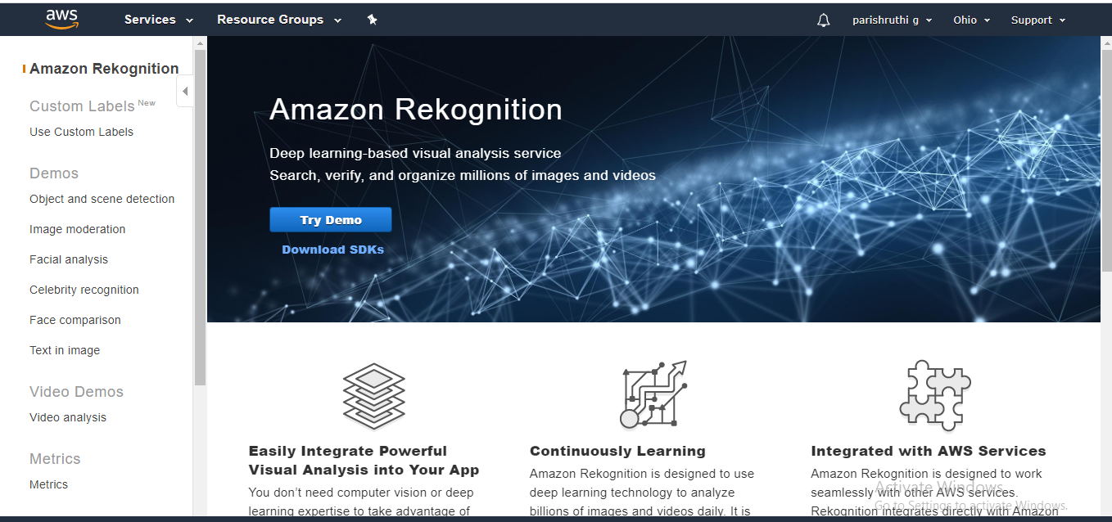

**EC2**

1. **CHOOSING AN AMI**

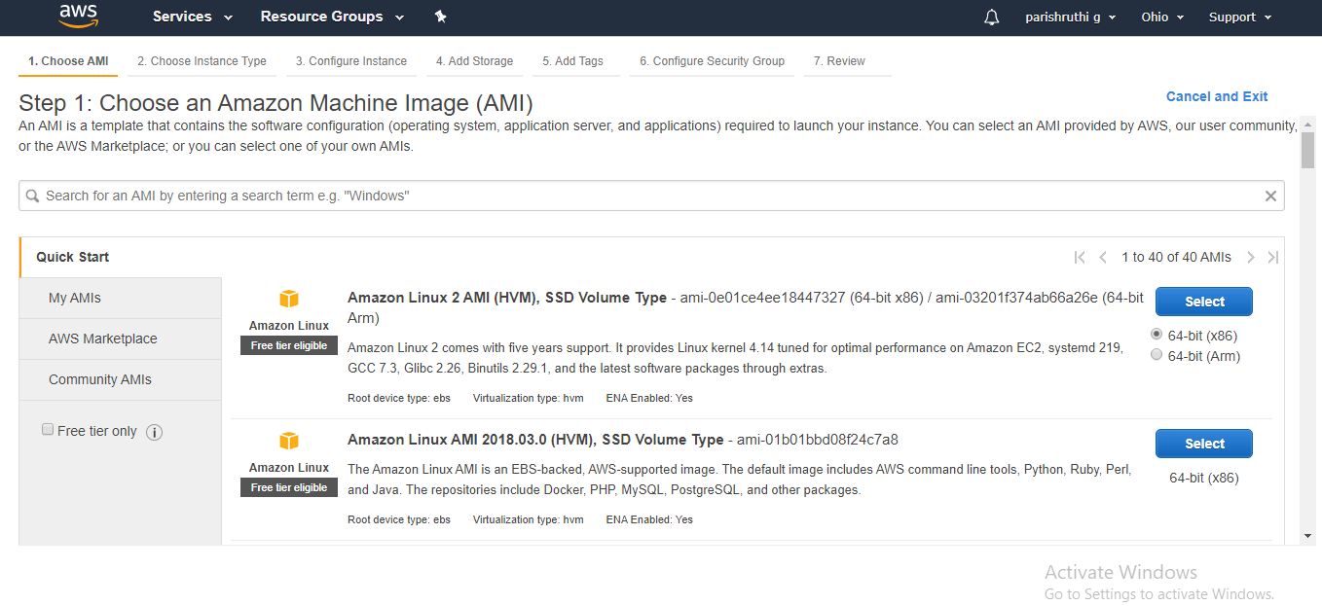

1. **CHOOSING A INSTANCE TYPE**

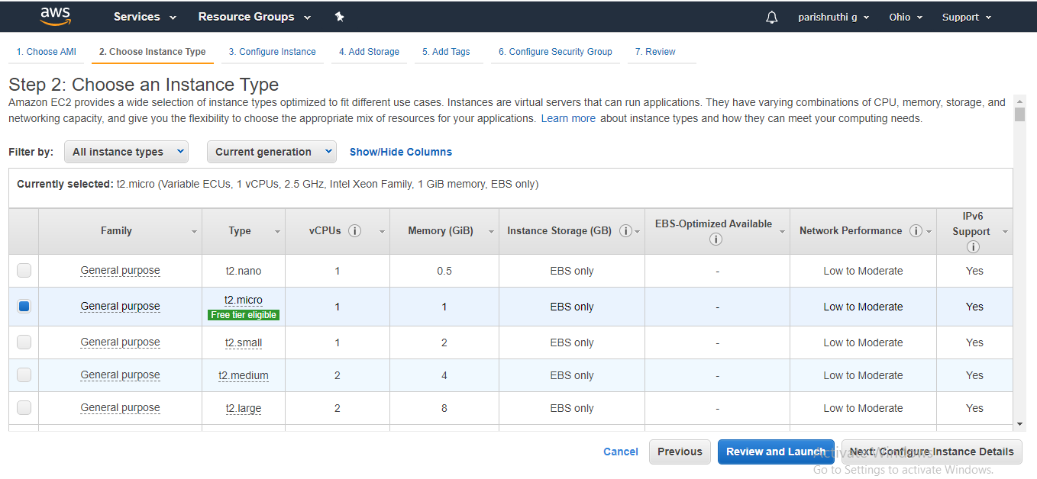

1. **ADDING STORAGE**

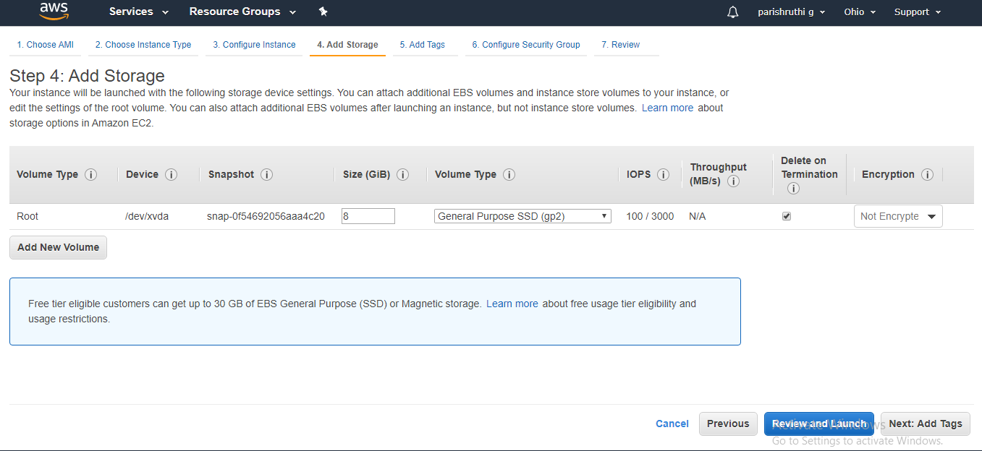

1. **CONFIGURE SECURITY GROUP**

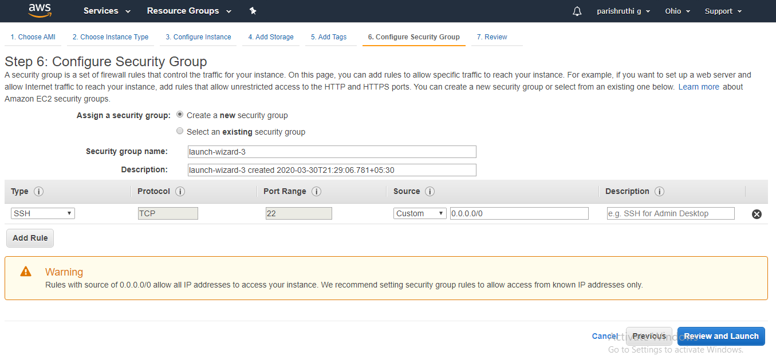

1. **KEY PAIR DOWNLOAD**

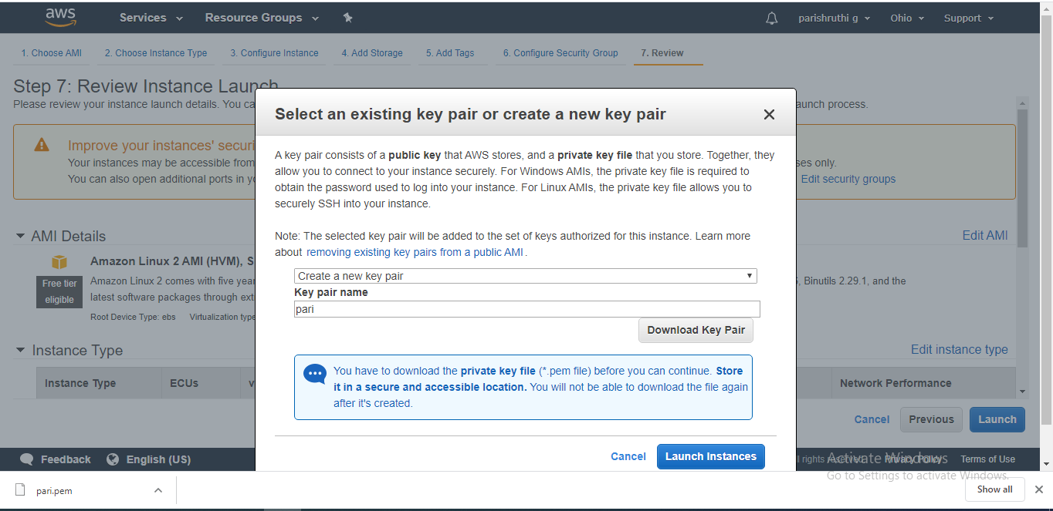

1. **PUTTYGEN CONVERSION FROMPEM TO PPK**

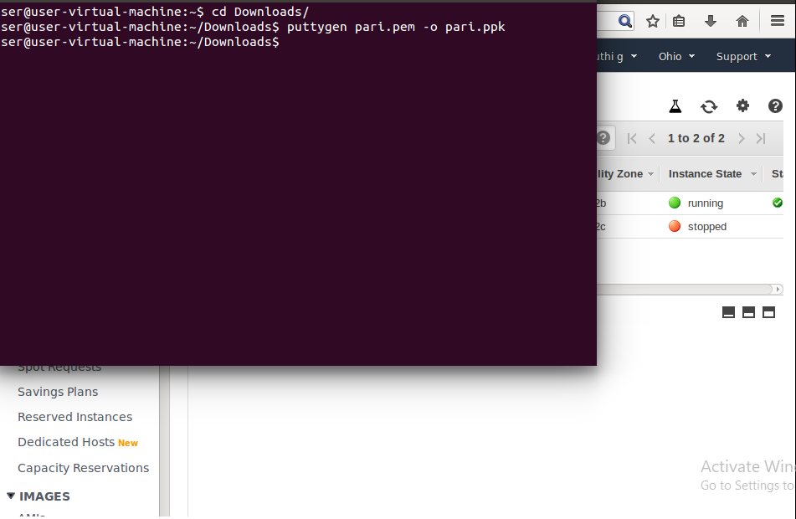

1. **LOGGED INTO EC2 PUTTY BLACK SCREEN**

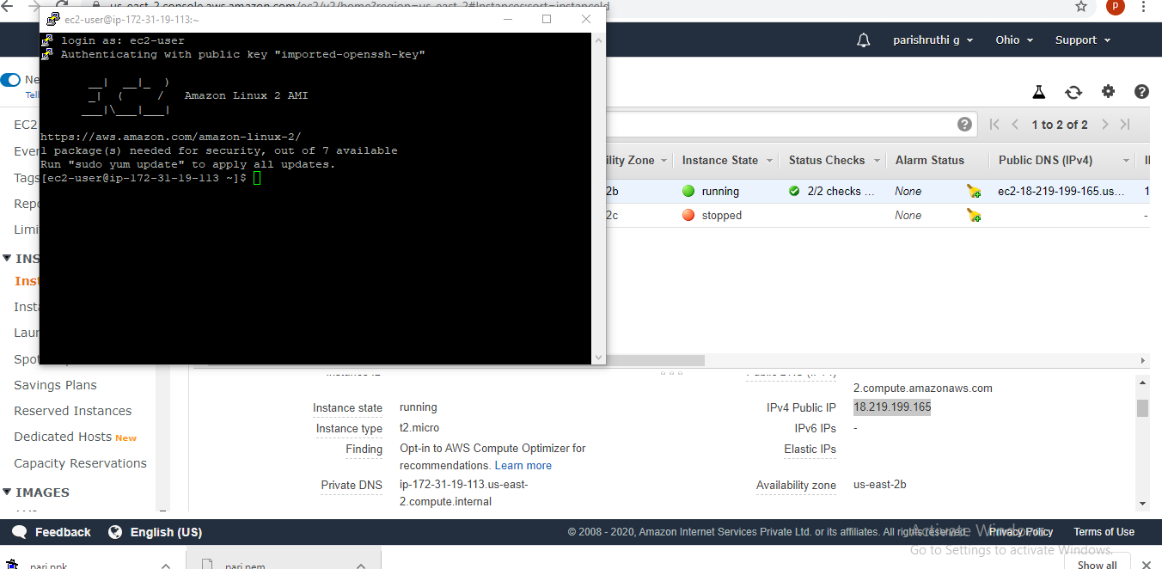

**S3**

1. **CREATING A BUCKET**

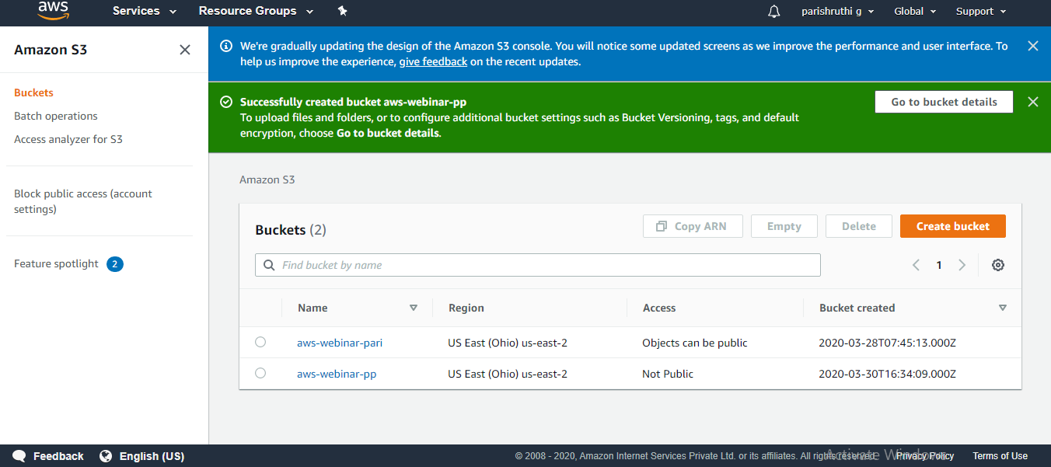

1. **UPLOADING AN OBJECT**

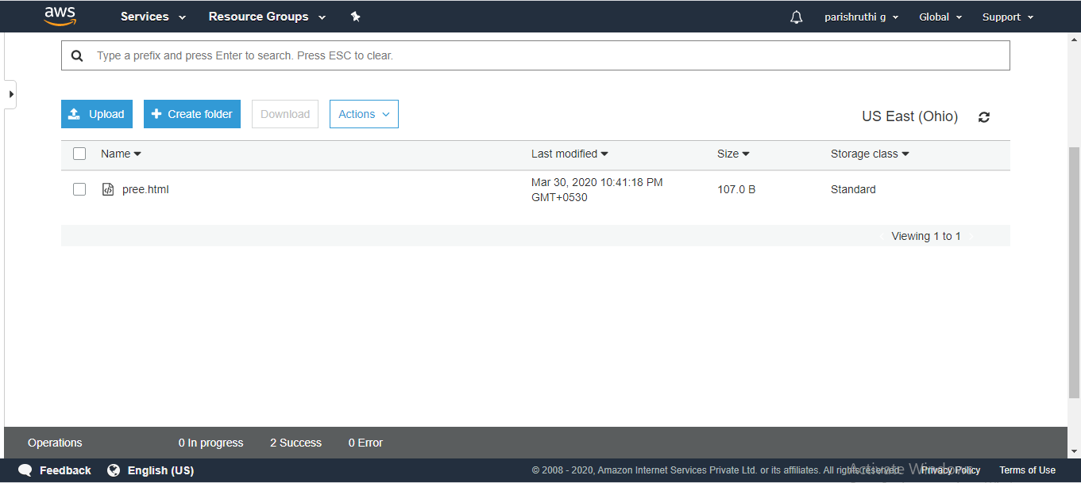

1. **ENABLE STATIC WEBSITE**

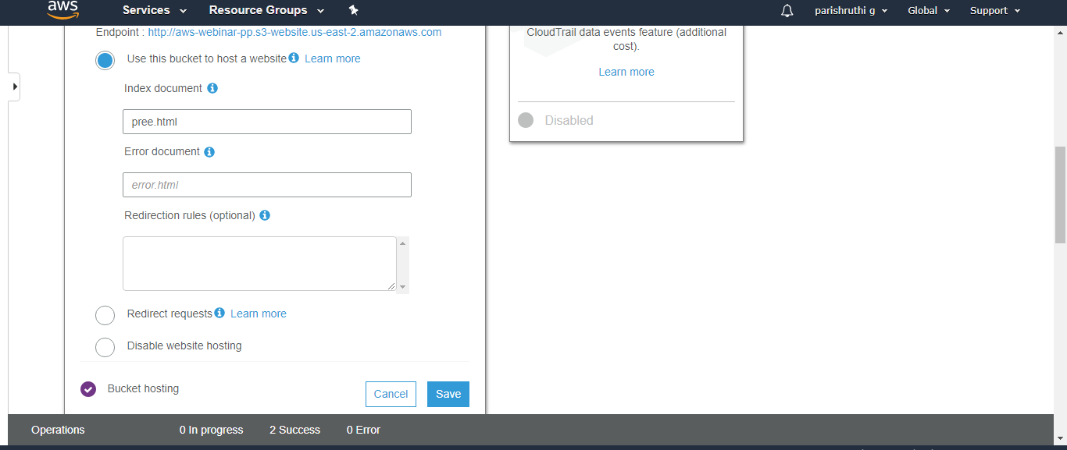

1. **MAKING THE OBJECT PUBLIC**

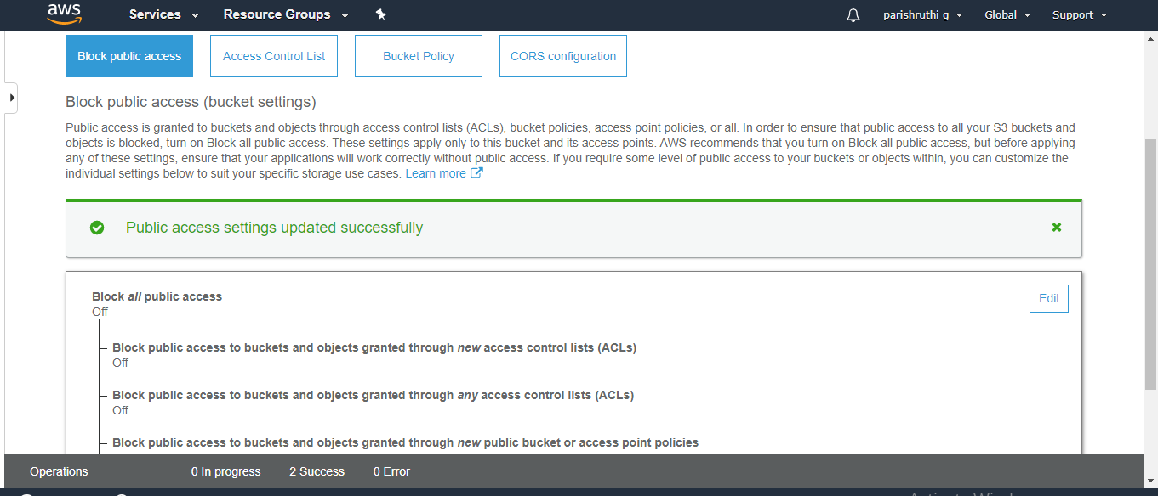

1. **CHECKING THE S3 LINK ON THE BROWSER**

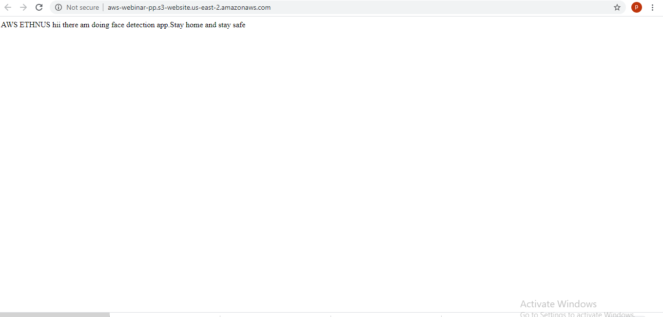

**REKOGNITION**

1. **FACE DETECT**

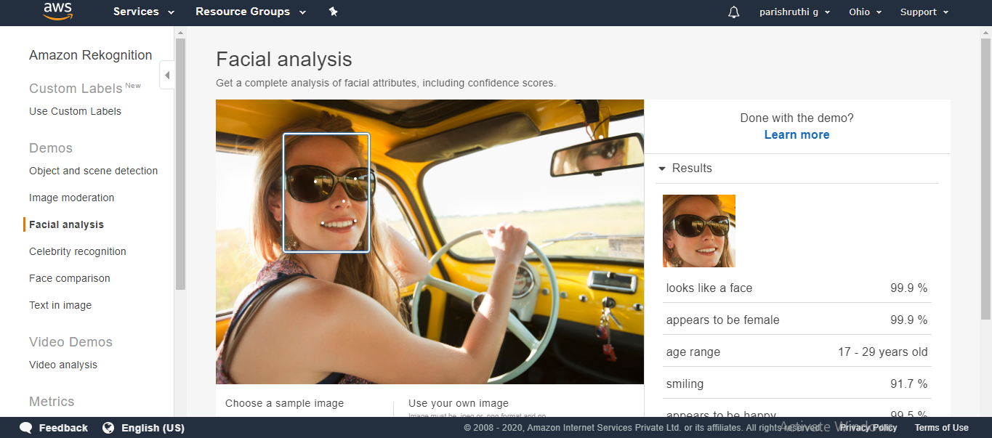

1. **FACE COMPARE**

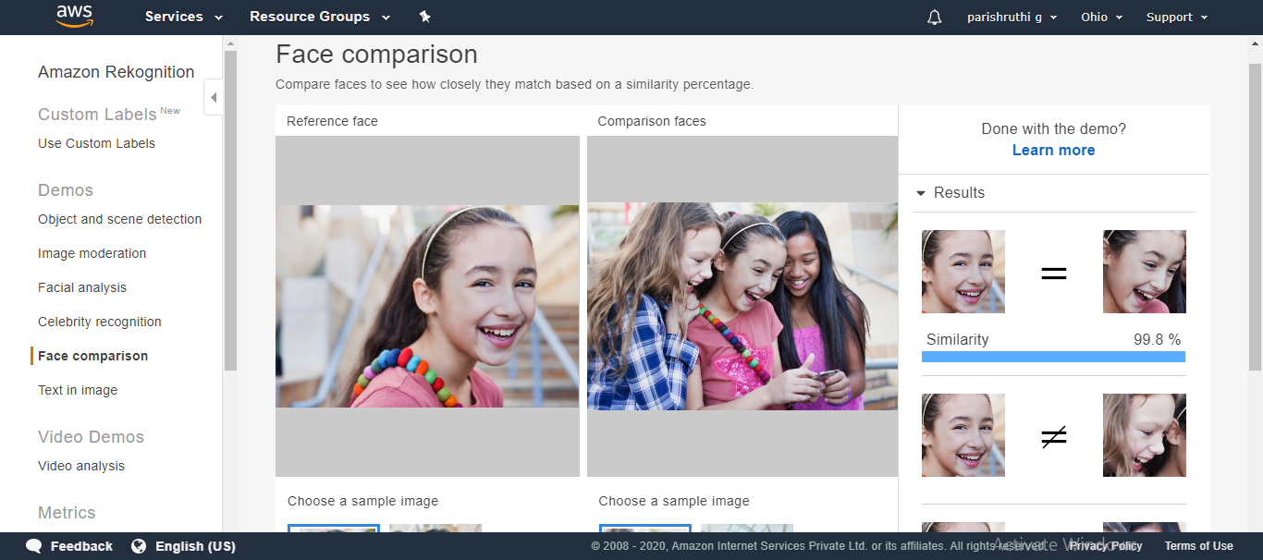

1. **TEXT IN IMAGE**

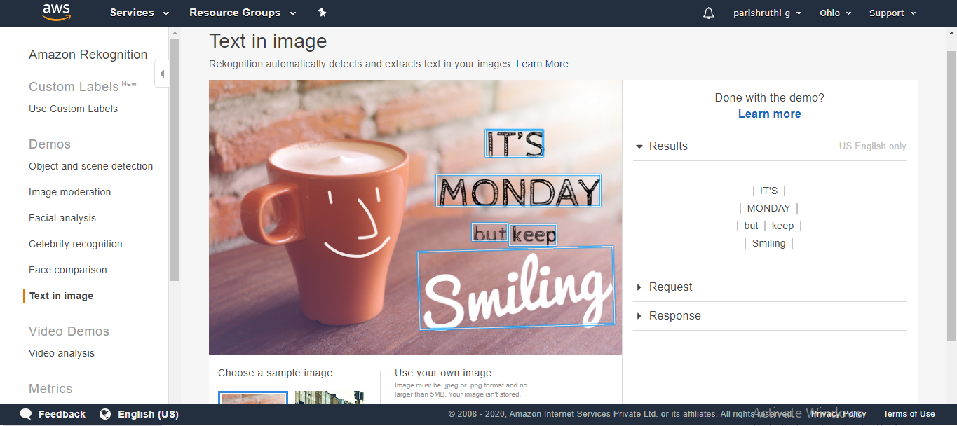

1. **CELEBRITY REKOGNITION**

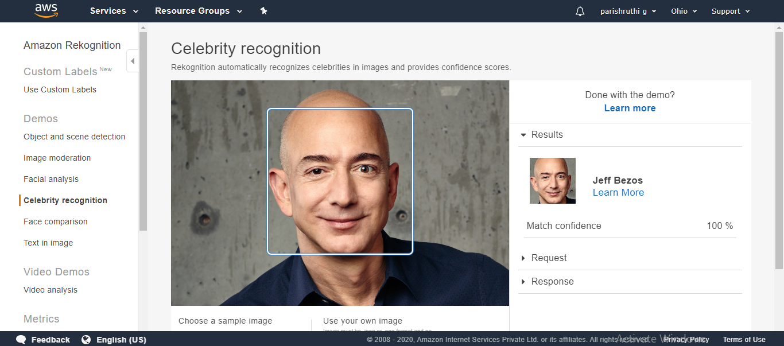

**EC2 AND S3**

1. **INSTALLING AWS-SDK**

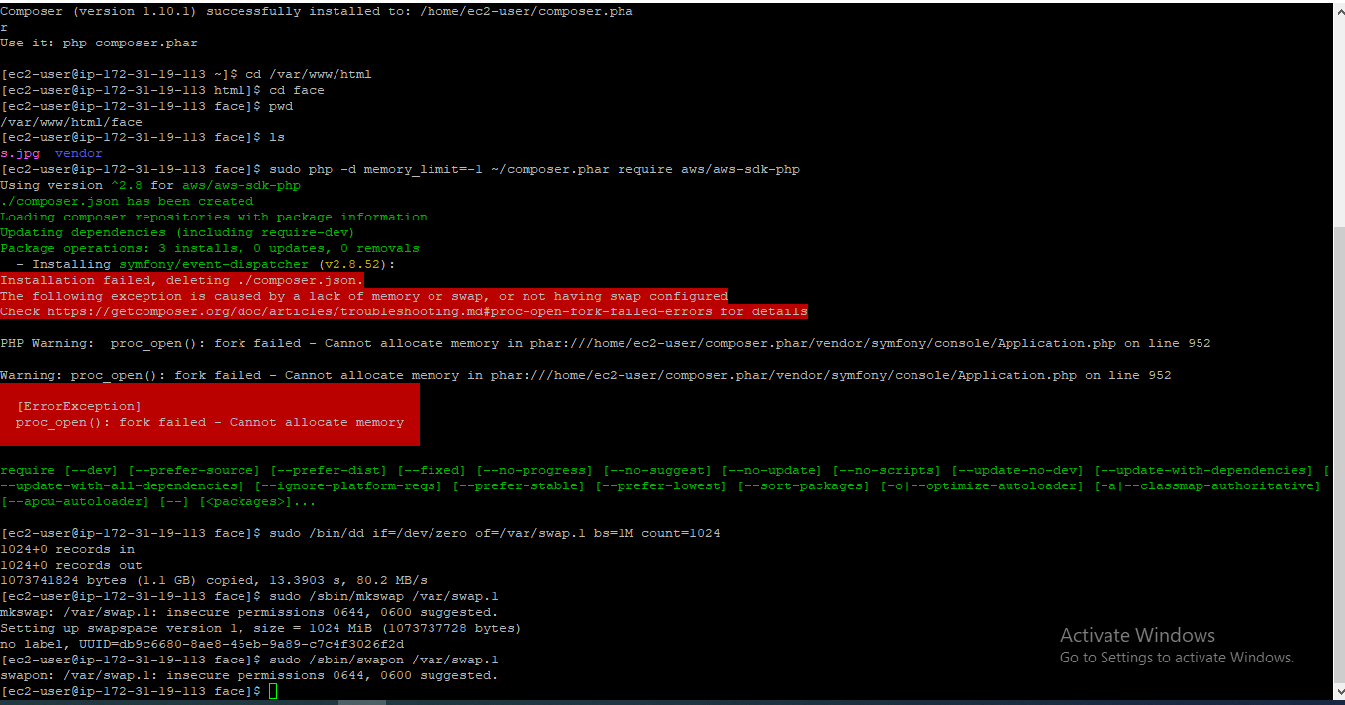

1. **INSTALLING PHP**

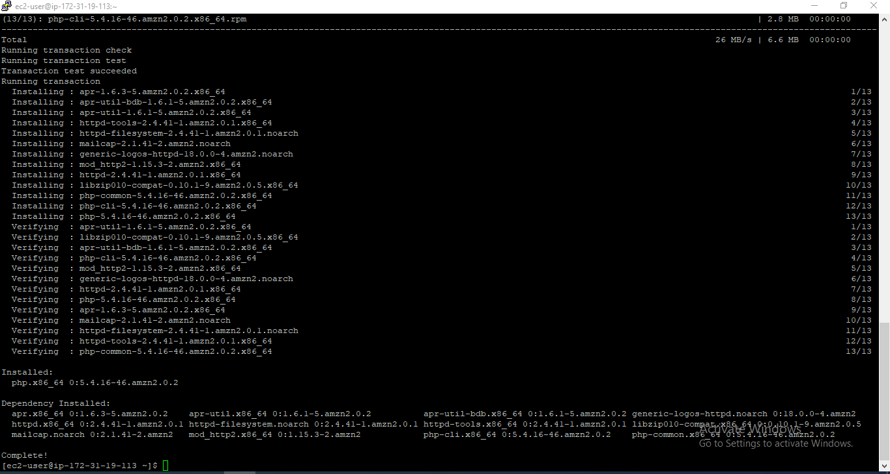

1. **INDEX.PHP FILE**

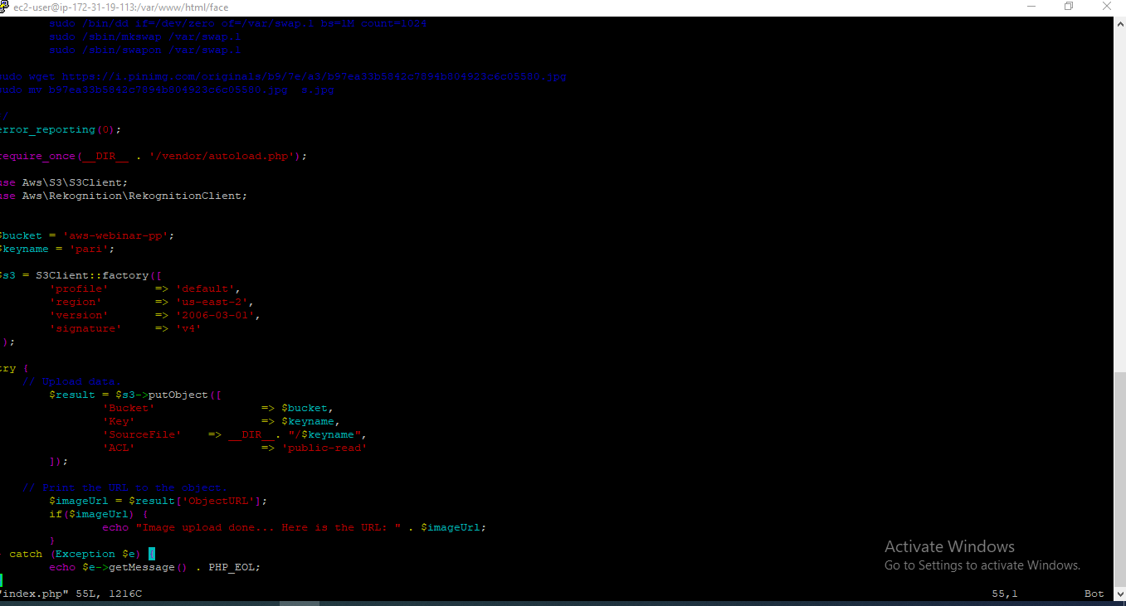

1. **UPLOAD SUCCESS SCREENSHOT**

